Laura Wilson LGW0020

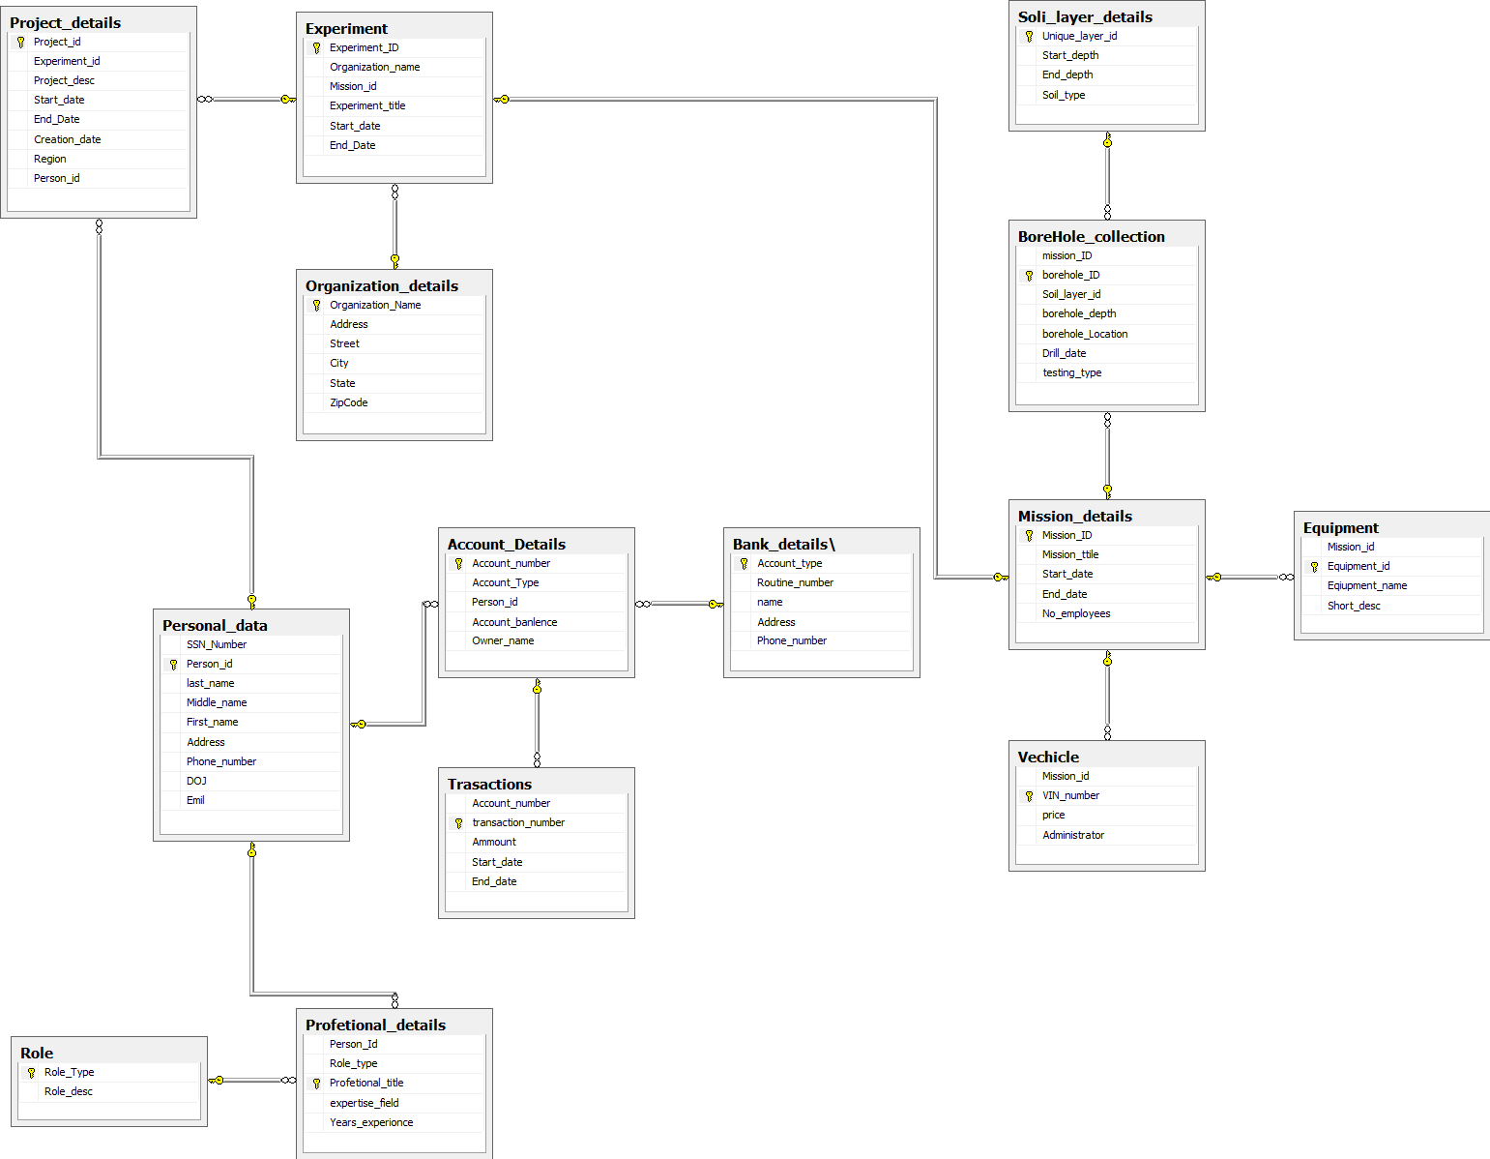

* **Entities and Attributes:**
  + **Project:** project_id (PK), title, start_date, end_date, creation_date
  + **Experiment:** experiment_id (PK), title, start_date, end_date, organization_name, organization_address, project_id (FK)
  + **Zip Code Region:** zip_code (PK), zip_code_area
  + **Personnel:** ssn (PK), last_name, first_name, middle_name, address, city, state, zip_code, phone_number, email
  + **Civil Engineer:** ssn (PK, FK to Personnel), field_of_expertise
  + **Field Operator:** ssn (PK, FK to Personnel), experience_years
  + **Computer Specialist:** ssn (PK, FK to Personnel), computer_skills
  + **Mission:** mission_id (PK), title, start_date, end_date, num_employees, experiment_id (FK)
  + **Equipment:** equipment_id (PK), name, description
  + **Excavator:** vin (PK), price, bucket_size, admin_ssn (FK to Personnel)
  + **Bulldozer:** vin (PK), price, horsepower, admin_ssn (FK to Personnel)
  + **Crane:** vin (PK), price, boom_length, admin_ssn (FK to Personnel)
  + **Centrifuge:** vin (PK), price, motor_power, admin_ssn (FK to Personnel)
  + **Drill:** vin (PK), price, diameter, admin_ssn (FK to Personnel)
  + **Borehole:** borehole_id (PK), depth, location, drill_date, testing_type, experiment_id (FK)
  + **Soil Layer:** layer_id (PK), start_depth, end_depth, soil_type, borehole_id (FK)

**Relationships:**

* + **Project - Experiment:** A project can have multiple experiments, but an experiment can only belong to one project. (1:N)
  + **Zip Code Region - Experiment:** An experiment can be conducted in one or more zip code regions, and each zip code region can be associated with multiple experiments. (N:M)
  + **Personnel - Mission:** A person can participate in multiple missions, and a mission can involve multiple persons. (N:M)
  + **Personnel - Equipment:** A person can be an administrator for multiple equipment, and an equipment can have only one administrator. (1:N)
  + **Mission - Equipment:** A mission can use multiple equipment, and an equipment can be used in multiple missions. (N:M)
  + **Experiment - Borehole:** An experiment can have multiple boreholes, and a borehole belongs to only one experiment. (1:N)
  + **Borehole - Soil Layer:** A borehole can have multiple soil layers, and a soil layer belongs to only one borehole. (1:N)
  + **Mission - Borehole:** A mission can involve multiple boreholes, and a borehole can be associated with multiple missions. (N:M)
  + **Personal Account - Bank:** A bank can have multiple personal accounts, and a personal account can belong to only one bank. (1:N)
  + **Business Account - Bank:** A bank can have multiple business accounts, and a business account can belong to only one bank. (1:N)
  + **Project - Personnel:** A person can participate in multiple projects, and a project can have multiple persons with different roles. (N:M)

**Explanation:**

Assumptions made:

* + A person can have only one social security number.
  + Each equipment can have only one type of machine, such as excav

Conceptual schema design for ALDOT geotechnical projects database:

Classes:

* + Project
  + Experiment
  + Person
  + Mission
  + Vehicle
  + Equipment
  + Borehole
  + Soil Layer
  + Zip Code Region
  + Bank
  + Account

Subclasses:

* + Employee (Person)
  + Civil Engineer (Employee)
  + Field Operator (Employee)
  + Computer Specialist (Employee)

Attributes:

* + Project: project_id (PK), title, start_date, end_date, creation_date
  + Experiment: experiment_id (PK), title, start_date, end_date, organization_name, organization_address(street, city, state, zip)
  + Person: ssn (PK), last_name, middle_name, first_name, address(street, city, state, zip), phone, join_date, email
  + Mission: mission_id (PK), title, start_date, end_date, num_employees
  + Vehicle: vin (PK), price, administrator
  + Equipment: equipment_id (PK), name, description
  + Borehole: borehole_id (PK), depth, location, drill_date, testing_type
  + Soil Layer: layer_id (PK), start_depth, end_depth, soil_type
  + Zip Code Region: zip_code (PK), polygon_area
  + Bank: routing_number (PK), name, address(street, city, state, zip), phone
  + Account: account_number (PK), balance, owner

Relationships:

* + Project-Experiment (one-to-many, strong): A project contains several experiments; an experiment belongs to one project.
  + Experiment-Zip Code Region (many-to-many, strong): An experiment can be conducted in multiple zip code regions; a zip code region can be associated with multiple experiments.
  + Experiment-Mission (one-to-many, strong): An experiment contains several missions; a mission belongs to one experiment.
  + Mission-Employee (many-to-many, strong): A mission can involve multiple employees; an employee can work on multiple missions.
  + Employee-Person (one-to-one, strong): An employee is a person; a person can be an employee.
  + Person-Civil Engineer (one-to-one, weak): A person can have a civil engineering expertise; a civil engineer is a person.
  + Person-Field Operator (one-to-one, weak): A person can have a field operation experience; a field operator is a person.
  + Person-Computer Specialist (one-to-one, weak): A person can have computer skills; a computer specialist is a person.
  + Mission-Vehicle (many-to-many, strong): A mission can use multiple vehicles; a vehicle can be used in multiple missions.
  + Mission-Equipment (many-to-many, strong): A mission can use multiple equipment; an equipment can be used in multiple missions.
  + Mission-Borehole (one-to-many, strong): A mission drills multiple boreholes; a borehole is drilled in one mission.
  + Borehole-Soil Layer (one-to-many, strong): A borehole contains multiple soil layers; a soil layer belongs to one borehole.
  + Project-Account (one-to-many, strong): A project has an account in a bank; an account belongs to one project.
  + Bank-Account (one-to-many, strong): A bank has multiple accounts; an account belongs to one bank.

Note:

* + PK denotes Primary Key.
  + We assume that each person can have only one SSN, and each vehicle can have only one VIN.
  + We assume that a zip code region is uniquely identified by its zip code.
  + We assume that a bank account can be either a personal account or a business account. If necessary, we can add an attribute to the Account class to represent the type of the account.